**Vallum Assignment**

1. **What is equity investing and how can you define it ?**

Equity investing involves of purchasing shares of publicaly traded companies with the expectation of earning a return on investment through capital appreciation (by increase in stock’s price) and dividends.

It is essentially buying ownership in a company . Suppose we take 1000 share of Tata Motors so that 1000 qty of my share is that my equity in that company .

**Capital Gains**: The increase in the value of the stock over time,allowing investors to sell the shares at a higher price than they were purchased.

**Dividends:** Regular payments made by the company to its

shareholders out of its profits

1. **Can you explain GARP Style of investing ?**

GARP (Growth At a Reasonable Price) investing is a strategy that seeks to identify companies that exhibit both growth potential and are priced reasonably relative to their growth prospects. In GARP investing, investors look for companies with solid growth potential in earnings, sales, or other fundamental metrics, but they also consider the current valuation of the stock to ensure it's not overpriced

1. **When analyzing companies listed on BSE & NSE, how do you differentiate between GARP style opportunities, growth-only, and value-only companies?**

To differentiate between GARP style opportunities, growth-only, and value-only companies when analyzing companies listed on BSE & NSE, you would typically look at various fundamental metrics such as earnings growth rate, revenue growth rate, price-to-earnings ratio (P/E ratio), price-to-book ratio (P/B ratio), and other valuation multiples. GARP opportunities would have a balance of growth potential and reasonable valuation compared to growth-only or value-only companies

Sure, here's a concise differentiation of GARP, growth-only, and value-only companies with examples from BSE & NSE:

**1. GARP (Growth at a Reasonable Price) Companies**

**Characteristics:**

* **Earnings Growth Rate:** 10-20%
* **Revenue Growth Rate:** Consistent, 10-12%
* **P/E Ratio:** 15-25
* **P/B Ratio:** Moderate

**Example:**

* **Infosys Ltd. (INFY)**
  + **Earnings Growth Rate:** 12-15%
  + **P/E Ratio:** ~20
  + **P/B Ratio:** ~6

**2. Growth-Only Companies**

**Characteristics:**

* **Earnings Growth Rate:** Above 20%
* **Revenue Growth Rate:** Rapid, above 25%
* **P/E Ratio:** Above 25
* **P/B Ratio:** High

**Example:**

* **Adani Green Energy Ltd. (ADANIGREEN)**
  + **Earnings Growth Rate:** Over 30%
  + **P/E Ratio:** Above 40
  + **P/B Ratio:** ~10

**3. Value-Only Companies**

**Characteristics:**

* **Earnings Growth Rate:** Below 10%
* **Revenue Growth Rate:** Low or stable
* **P/E Ratio:** Below 15
* **P/B Ratio:** Low

**Example:**

* **Coal India Ltd. (COALINDIA)**
  + **Earnings Growth Rate:** 5-7%
  + **P/E Ratio:** ~8
  + **P/B Ratio:** ~1

**Summary**

* **GARP:** Balanced growth and valuation (e.g., Infosys)
* **Growth-Only:** High growth, high valuation (e.g., Adani Green Energy)
* **Value-Only:** Low growth, low valuation (e.g., Coal India)

1. **How comfortable are you with Python? Please provide details about your knowledge and practical application level?**

.I'm quite comfortable with Python. I have knowledge of core Python concepts like data types, control flow, functions, and modules, as well as libraries commonly used in data analysis and web scraping like Pandas, NumPy, BeautifulSoup, and Scrapy. I've also been trained on various Python projects and have practical experience applying Python for data analysis, scripting, and automation tasks.for example i have created a fake data using faker libraries. Few snnipets of my code is below…

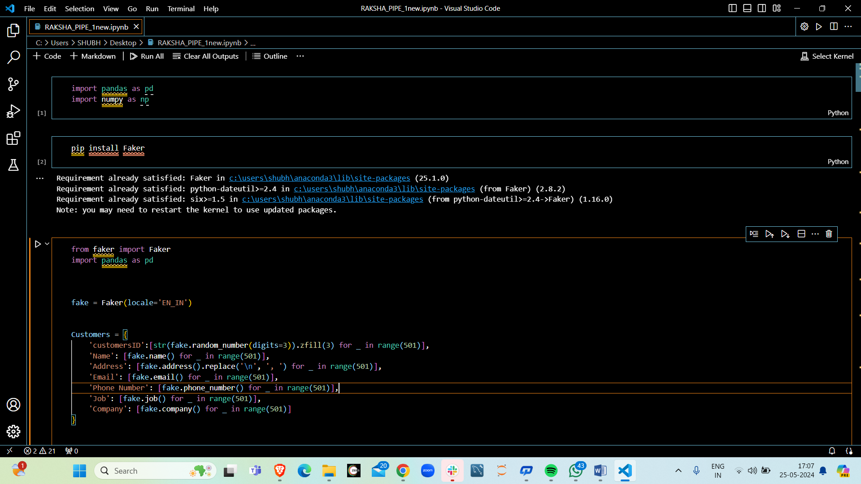

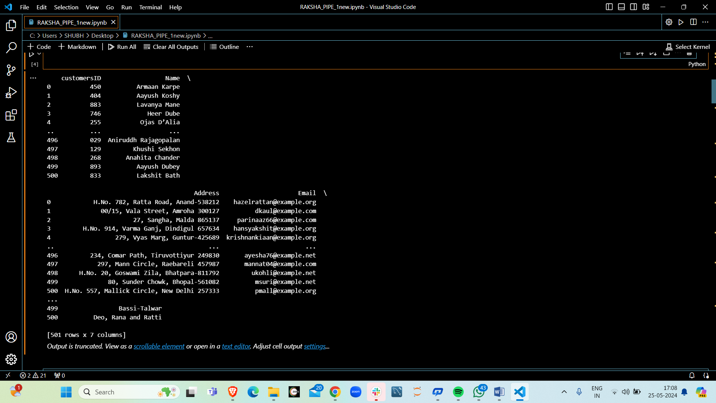

1. **Using python how would you determine if a company listed on BSE & NSE follows the GARP style, considering the available data for approximately 6000 companies?**

To determine if a company follows a GARP style using python you would typically gather financial data for companies listed in BSE & NSE To determine if a company follows the GARP style using Python, you would typically gather relevant financial data for the companies listed on BSE & NSE and then analyze metrics such as earnings growth rate, revenue growth rate, and valuation multiples like P/E ratio and P/B ratio. You can write Python scripts using libraries like Pandas to manipulate and analyze the data, and then apply logic to identify companies that exhibit both growth potential and reasonable valuation

1. **Based on your knowledge, what insights can you derive and showcase about the following stocks: SBIN, Adani Enterprises, HUL, Tata Steels, Moil?**

Insights about the mentioned stocks (SBIN, Adani Enterprises, HUL, Tata Steels, Moil) could include analyzing their financial performance, market trends, recent news or events related to the companies or their industries, and comparing them to industry peers. However, due to the limitations of this format, I can't provide real-time data or analysis.

1. **State Bank of India (SBIN)**

Sector: Banking and Financial Services

Market Position: SBI is India's largest public sector bank with a significant market share in deposits, loans, and overall banking services.

**2. Adani Enterprises**

Sector: Conglomerate (Diversified interests including ports, energy, and logistics)

Market Position: A key player in several infrastructure sectors, particularly known for its rapid expansion in the renewable energy space.

**3. Tata Steel**

Sector: Steel Manufacturing

Market Position: One of the top steel producers globally, with a strong presence in both domestic and international markets.

**4. MOIL (Manganese Ore India Limited)**

Sector: Mining (Manganese Ore)

Market Position: Largest producer of manganese ore in India, supplying to major steel manufacturers.

Summary

* SBI: Positioned well for growth with strong fundamentals in the banking sector.
* Adani Enterprises: High growth potential, but with significant debt and regulatory risks.
* HUL: Consistent performer with strong market position and growth driven by consumer trends.
* Tata Steel: Benefiting from infrastructure

1. **Are you familiar with web scraping techniques?**

Yes, I am familiar with web scraping techniques. Web scraping involves extracting data from websites using automated scripts. Here’s a brief overview of the process and tools used:

### Web Scraping Overview

#### 1. **Understanding the Website Structure**

* **HTML Elements:** Websites are structured using HTML. Understanding the HTML tags and elements (like **<div>**, **<span>**, **<table>**, etc.) is crucial.
* **Inspecting Elements:** Use browser developer tools (right-click on a webpage and select "Inspect") to examine the structure of the webpage and identify the data you want to extract.

#### 2. **Choosing the Right Tools and Libraries**

* **Python Libraries:** Common libraries for web scraping in Python include:
  + **BeautifulSoup:** For parsing HTML and XML documents.
  + **Requests:** For making HTTP requests to fetch the webpage content.
  + **Selenium:** For scraping dynamic websites that require JavaScript execution.
  + **Scrapy:** A powerful and flexible web scraping framework.

#### 5. **Storing the Extracted Data**

* **CSV/Excel Files:** Use libraries like **pandas** to store data in CSV or Excel format.
* **Databases:** Store data in databases like SQLite, MySQL, for more complex applications.
* By following these steps, you can efficiently scrape data from websites and handle various complexities such as dynamic content and anti-scraping measures.

**8.Extracting NRI Data from SEBI Reports**

To extract NRI (Non-Resident Indian) data from SEBI (Securities and Exchange Board of India) reports, follow these steps:

**1. Access SEBI Reports**

* Visit the SEBI official website: [SEBI Reports](https://www.sebi.gov.in/)
* Navigate to the "Reports and Statistics" section.
* Look for relevant reports such as "Mutual Fund Reports," "Market Data Reports," or any specific reports on NRI investments.

**2. Identify Relevant Sections**

* Open the report and identify sections that mention NRI investments, such as:
  + **NRI Investments in Mutual Funds**
  + **NRI Participation in IPOs**
  + **NRI Equity and Debt Holdings**

**3. Extract Data**

* Use tools like **Adobe Acrobat Reader** for PDFs to highlight and copy relevant sections.
* For more advanced data extraction, use **Python** with libraries like **PyPDF2** or **tabula-py**.

### 4. Example: Extracting Data with Python

Install necessary libraries:

**5. Process and Analyze Data**

* **Cleaning Data:** Use Pandas for data cleaning and processing.
* **Analysis:** Perform necessary analysis to derive insights on NRI investments.

**6. Automate the Process**

* Schedule the script using a task scheduler (Windows Task Scheduler, cron jobs in Linux) to periodically extract and process data from new SEBI reports.

By following these steps, you can efficiently extract, process, and analyze NRI data from SEBI reports.

**9. Necessary Device Configuration**

To perform these tasks daily, you would need:

#### Hardware Requirements

* **Computer:** Intel i5/i7 or AMD Ryzen, 8GB RAM (16GB recommended), 256GB SSD (512GB recommended)
* **Internet:** Reliable broadband, 25 Mbps minimum
* **Monitors:** Dual monitors (optional but recommended)

#### Software Requirements

* **OS:** Windows 10/11, macOS, or Linux (Ubuntu)
* **Financial Analysis Tools:**
  + **Microsoft Excel** or **LibreOffice Calc**
  + **Python/R Programming** (Jupyter Notebook for Python, RStudio for R)

#### Python Libraries

* **Pandas, NumPy:** Data manipulation and numerical computations
* **Matplotlib/Seaborn:** Data visualization
* **Scikit-learn:** Machine learning for financial modeling

#### Data Sources

* **APIs:** Yahoo Finance, Alpha Vantage
* **Financial Databases:** Moneycontrol, Screener.in, NSE/BSE websites
* **Financial News:** Reuters, Bloomberg, Economic Times